June 22, 2001

«PREFNAME1»
«PREFNAME2»
«ADDRESS1»
«ADDRESS2»
«ADDRESS3»
«CITY» «STATE» «POSTALCODE»

Dear «SALUTATION»,

Earlier this year you received a letter from us regarding the Erb Memorial Union’s celebration of fifty years of service to the University of Oregon. We recently commemorated this milestone at a luncheon reception held at the EMU's Taylor Lounge during our 50 year Reunion Weekend. The luncheon was a great success so we hope you were able to attend.

As you may recall, the EMU was the heart of campus life when it first opened in 1951. Today, the EMU continues to be the busiest and most dynamic place on campus. Every day thousands of UO students, staff and visitors take advantage of dozens of convenient services or participate in one of the numerous cultural or recreational programs. We are very proud of its success and hope that you, as one of the first EMU patrons, will recognize the EMU's progress with your support.

Although much of the building has been updated over the past few years, improvements must continue in order to provide the best possible service to everyone on campus. This year, in honor of our 50th Reunion, the Class of '51 hopes to contribute $25,000 toward the updating of the EMU's Taylor Lounge, the official "living room" of the student union. Created in memory of Tom Taylor, a former UO student who died while serving in WWII, the lounge has always served as an inviting haven for students and campus visitors alike. Work is underway to return the room to its original luster with newly upholstered furniture, brightly colored carpets, soft lighting, original artwork, restored woodwork, and warm fires blazing once again in the large ornate fireplace.

With your support, we can return the Taylor Lounge to its former elegance and make it just as special today as it was when we were students. You may not know that the EMU is funded primarily by student fees. As you can imagine, it is a constant challenge to keep this student expense affordable while preserving high quality service. Your gift, no matter the size, will have a significant impact on today's students.

This is your last chance to participate so please return the enclosed pledge card today. Thank you for your support of the Taylor Lounge renovations, a lasting legacy to the great Class of '51.

Sincerely,
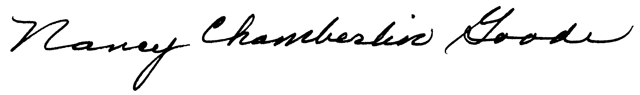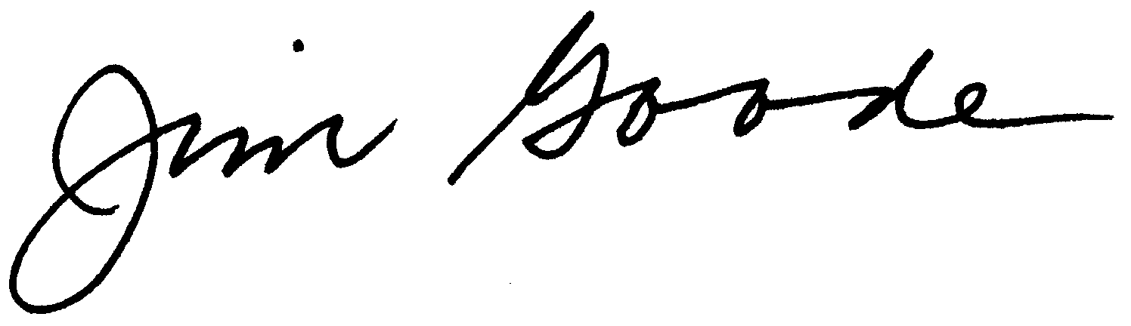
Nancy Chamberlin Goode, Class of 1951 James Goode, Class of 1951

